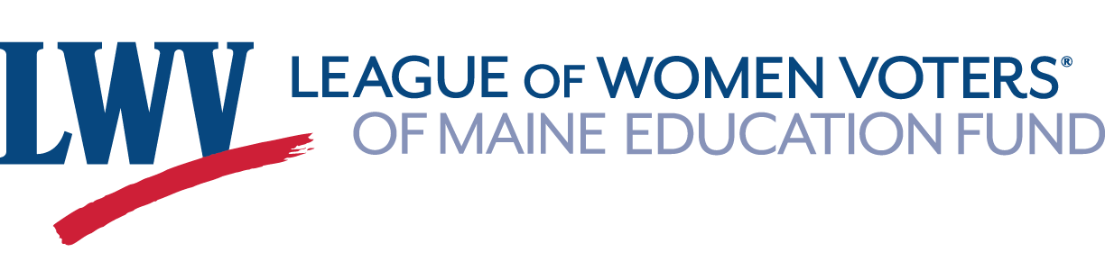
Volunteer Guidelines for Naturalization Ceremonies - Thank you for volunteering to help register new citizens to vote at Naturalization Ceremonies. Your volunteer registration efforts represent the nonpartisan nature of the voter services work of the League of Women Voters. The ceremonies are usually very poignant events, with family and friends there to lend support.
- Types of Ceremonies
  - Administrative - conducted by members of the U.S. Citizenship and Immigration Services (USCIS).
  - Judicial - presided over by one or more Federal judges and often more formal in nature.
- Venues – Events take place in a variety of locations.
  - USCIS Field Office, 176 Gannett Drive in South Portland
  - Gignoux Courthouse, U.S. District Court, 156 Federal St. in Portland
  - Margaret Chase Smith Federal Building and Courthouse, 202 Harlow St. in Bangor
  - Schools and veterans’ homes
  - Acadia National Park
- Times & Preparation
  - Ceremonies at USCIS are usually in two sessions, 9:00 AM & 11:00 AM, for about 15 new citizens each. The room is small and can be quite crowded. Citizens receive their certificates individually during the ceremony. Registering new citizens to vote takes place in the outer lobby after the ceremony.
  - Ceremonies at courtrooms and schools are usually at 10 AM and involve larger numbers of new citizens. Certificates are distributed after the event. A location is selected for new citizen voter registration.
  - Leave yourself plenty of time to be at the event at least 15 minutes before the ceremony starts. Depending on the location, there may be a security check to enter the building, so have a photo ID with you. Parking may be an issue.
  - If this is your first time, plan to arrive 1/2 hour before to review procedures.
- Background Information
- The State of Maine Voter Guide explains how to register and vote, and includes a sample voter registration card. http://www.maine.gov/sos/cec/elec/voter-info/voterguide.html
- Review the League document, Volunteer Guidelines for Voter Registration Drives, to make sure you are familiar with your responsibilities. www.lwvme.org/files/Volunteer_Guidelines_for_Voter_Registration_Drives.pdf
- The League’s Making Your Vote Count brochure is handed out to each new citizen. http://www.lwvme.org/files/Voting_Brochure_2016.pdf
- Other Important Considerations
  - Casual business attire is appropriate for these celebrations. No jeans please.
  - Our role is to help register new voters and to encourage them to become informed about the issues and candidates. To remain focused and nonpartisan at all times, it is best not to discuss politics, including current events.

